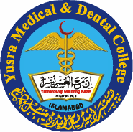
YURSA MEDICAL AND DENTAL COLLEGE
Islamabad Pakistan
APPLICATION FORM (MBBS)
(Prior to Filling the Form Please Read the Instructions Carefully)
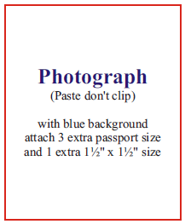
Application for Admission in Session Click here to enter text.

Pakistani Citizen ☐ Expatriate ☐ Foreigner ☐

Yes ☐ No ☐

Name of Student Mr./Miss. Click here to enter text.
(Capital Letters) (As per Matriculation certificate)

Date of Birth Click here to enter a date. Gender M ☐ F ☐ Blood Group Choose an item. Disability Click here to enter text.

NIC Card # Click here to enter text. B Form # Click here to enter text. Marital Status Click here to enter text.
(Attach photocopy) (Attach photocopy)

Religion Choose an item. Domicile (District/Province) Click here to enter text.

Name of Father/Guardian Click here to enter text.

NIC Card # Click here to enter text.
(Attach photocopy)

Profession/Designation of Father/Guardian Click here to enter text.

Postal Address Click here to enter text.

Permanent Address Click here to enter text.

Email Click here to enter text. Tel No Click here to enter text. Mob Click here to enter text.
(Tel / Mobile # be written with country and city code)

Processing Fee Paid by Draft/Cash/Pay Order Click here to enter text.

Passport No Click here to enter text. Valid upto Click here to enter text.
Type of Visa Click here to enter text. Valid upto Click here to enter text.

Tel No. Click here to enter text. Mob No. Click here to enter text.
Academic Record
If any of the academic record asked has’nt been submitted, the application will be treated as “Provisional” and subject to cancellation unless the Admission Office receives all record within one week of closing date. (attach attested photocopies)
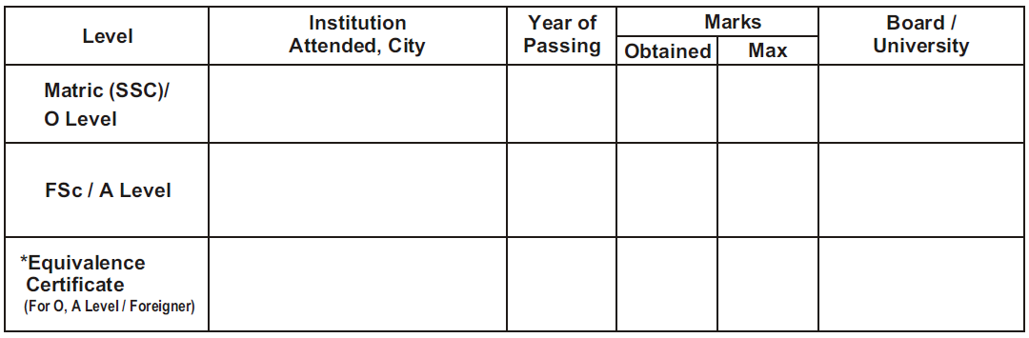

Extracurricular
Hobbies/Games Click here to enter text. Distinction (if any) Click here to enter text.
I declare that the above information provided by me is true to the best of my knowledge and belief. If anything found incorrect at any stage, the YM&DC authorities have the right to cancel my admission. I have read and understood the college prospectus and the admission procedure. I agree to abide by the rules and regulations of Yusra Medical & Dental College about selection, discipline and other academic affairs.

_________________
Signature of Student

Place _____________

Date _____________
Signature of
Parents/Guardian

Place _____________

Date _____________

Left Thumb Impression
(In box)

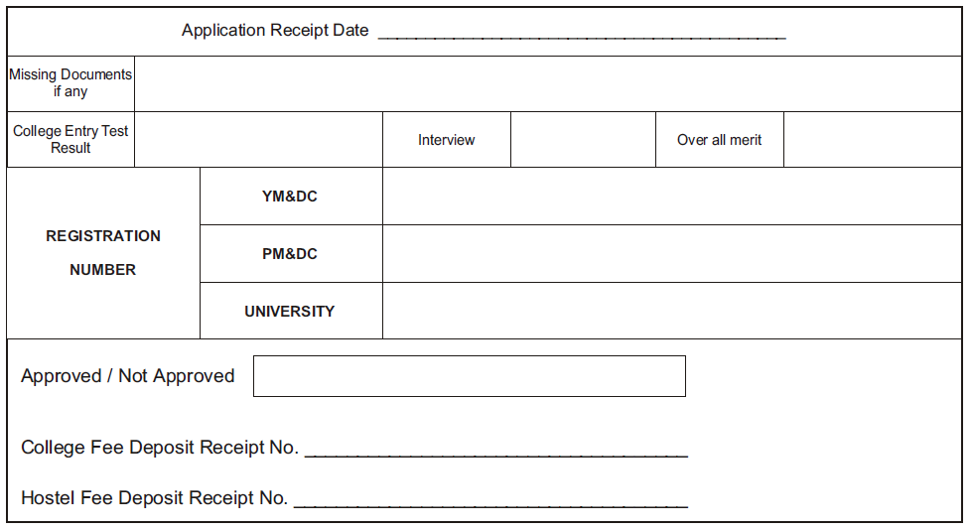
FOR OFFICE USE ONLY

Signature Signature
Superintendent Student Affairs College Authorities

